**Documentation**

*Team Musketeers*

*Date: 10.06.2022*

# Team members

Abdul-Azeez Olanlokun 2180593

Elijah Nnamdi Obi 2190345

George Izuchukwu Enekwa 2190317

Patric Nonki 2190336

# Concept description

**State diagram of our target application.**

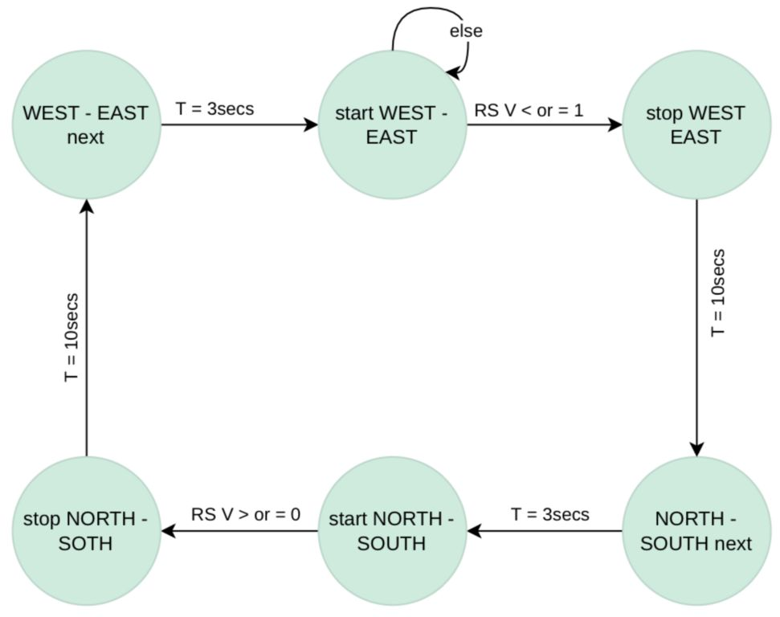

**TRAFFIC LIGHT CONTROLLER:** In our system, there is a sensor in the nearby street to detect if there is any vehicle on that way. If vehicles are detected on the street, traffic light on the high way turns to YELLOW, then RED so that the vehicles from the street can cross the high way. Otherwise, the traffic light on the high way is always GREEN and traffic light on the street is always RED. The time period is 3 seconds for the YELLOW light and 10 seconds for the RED light.

The system is implemented this way to give priority to the high way due to the frequency of motorists plying this way in comparison to the street way.

# Technologies used

*We use the following application for our project:*

* *ModelSIM dor VHDL code implementation, testbench, wave simulation*
* *EAGLE CAD for PCB realization*

# Project/Team management

*Which project methods you used in your project?*

The project management method used was agile methodology, specifically scrum, where we had weekly sprint sessions(physically). Complex tasks were broken down to smaller bits and assigned to individuals*.*